|  |  |  |
| --- | --- | --- |
|  |  | **Steps to link the azure chat bot to facebook channel** |
| Step 1 | Login into the azure portal and go to channels and choose Facebook canhnel |  |
| Step 2 | Login to Facebook developers to create application   * Mention the app name and click create then a application will be created . |  |
| Step 3 | Go to dashboard and scroll down to ADD TO PRODUCT in this add messenger and webhooks to application |  |
|  | Change the seeting .  Goto settings of app 🡪advanced settings🡪allow API ACCESS TO APP SETTING (yes ) |  |
| Step 4 | Click on messenger on left side of screen and go to setting under the messenger. |  |
| Step 5 | i) Now create / add your facebook page to your to access tokens and ii ) click generate token to get page access token . save this page access token to use in facebook channel in azure .  Page access token will wil value 4 in below steps … |  |
| Step 6 | Next in webhooks enter the values the values from the azure facebook channel to webhooks values |  |
| Step 7 | Click on add subcriptions . and add  Select the below 4 options and click save . |  |
| Step 8 | Go to azure facebook channel and enter the values .   1. App id 2. App screct key 3. Page id 4. Page access token   See below steps to get these values…… |  |
| Step 9 | For 1)app 1d and 2)app secret  Go to facebook developer 🡪setting 🡪basic settings🡪you can see app id and secret key here . |  |
| Step 10 | For value 3  Goto facebook page you have created now and goto 🡪 about🡪you can see page id here . |  |
| Step 11 | Foe value 4 .goto step 5 in this document and get that stored value / or again generate it by clicking generate token . |  |
| Step 12 | Now finally click save. |  |

**Test the facebook page**

**Goto your page and click on the send message 🡪 test button 🡪 now a chat box ap 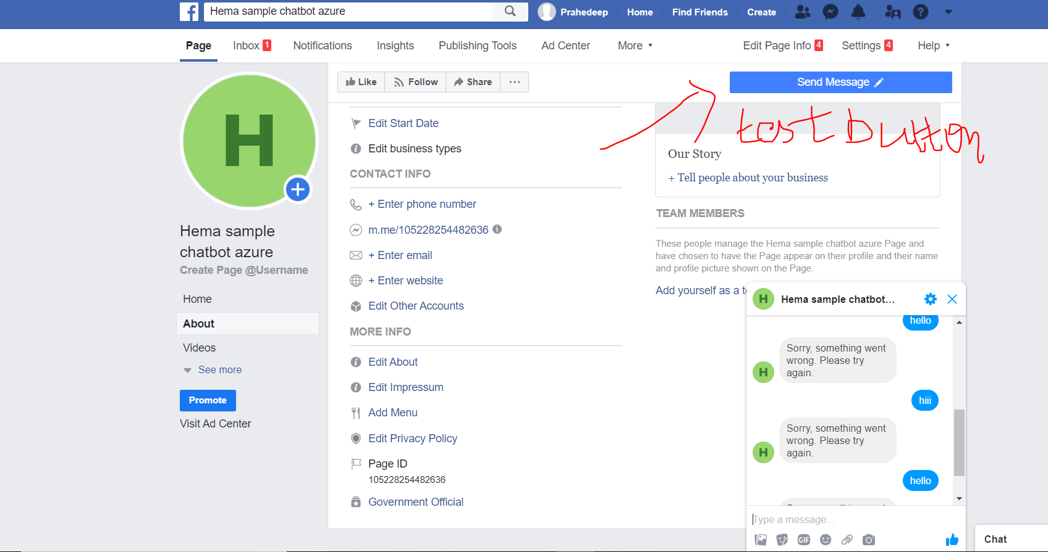pears to chat 🡪 now type a message and chat with our bot.**

**Thanks**